Welcome!
Date
Name
Spouse
Address
City
State Zip _________
Email

Please Contact By
❑ Card  Phone  Visit

Telephone Best Time to Call
Home ______________
Work ______________

Guest: First Time Second Time
Are you a church member: yes no
Church
City, State

Circle Appropriate Age/Grade Group(s)
Preschool: Ages: B-1 2-3 4-5
Children: Grades: K 1 2 3 4 5 6
Youth: Grades: 7 8 9 10 11 12
Adults: Ages:18-29 30s 40s 50s 60s+

How did you learn about our church?
Newspaper Friend Yellow Pages Mail
Other

I am a guest of:

New in the Community? Yes No
Names & ages of children at home

Weekly Service & Activity Schedule

Apr 30, 2017
9:45 a.m. Sunday School
11:00 a.m. Worship Service
6:00 p.m. “The Burden of a Lesser God”

Week of Apr 30, 2017

Wednesday 6:30 pm………………..…Meal/Bible Study
Friday 6:30 pm……………..……………..Men’s 42 Night

May
7……………………………………New Commandment Kids
11…………………………………….………Adult Fellowship
14…………………………………..New Commandment Kids
14………………….………….Independance Music Festival
21…………………………..….Graduate Recognition Lunch
21……………………………………..…….Business Meeting
25…………………………………………….Adult Fellowship

Join us Sunday evenings for a video series from bestselling author Max Lucado entitled

“Traveling Light – A Journey through Psalm 23”


If you have a graduate you would like to recognize at the Graduate Lunch on May 21 please let Brother David or Patti Radford know. High School, College, Trade School

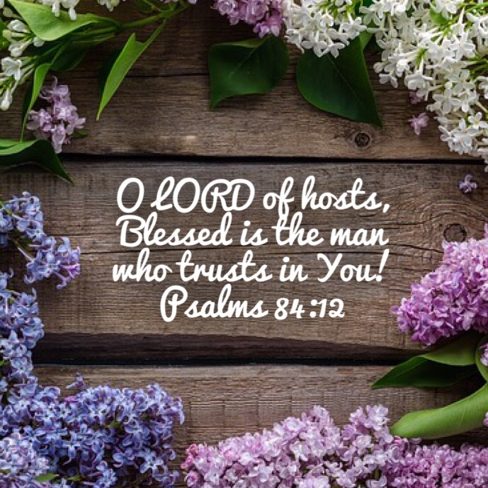

Knobbs Springs Baptist Church

April 30, 2017

Church Information:

KnobbsSpringsBC.com KnobbsSpringsBaptist@gmail.com

1662 CR 305, McDade, Texas 78650 512-273-2743

David Atwood, Pastor Cell 512-470-5098

Patti Radford, Office Manager Cell 512-968-7821

